Terminal 4
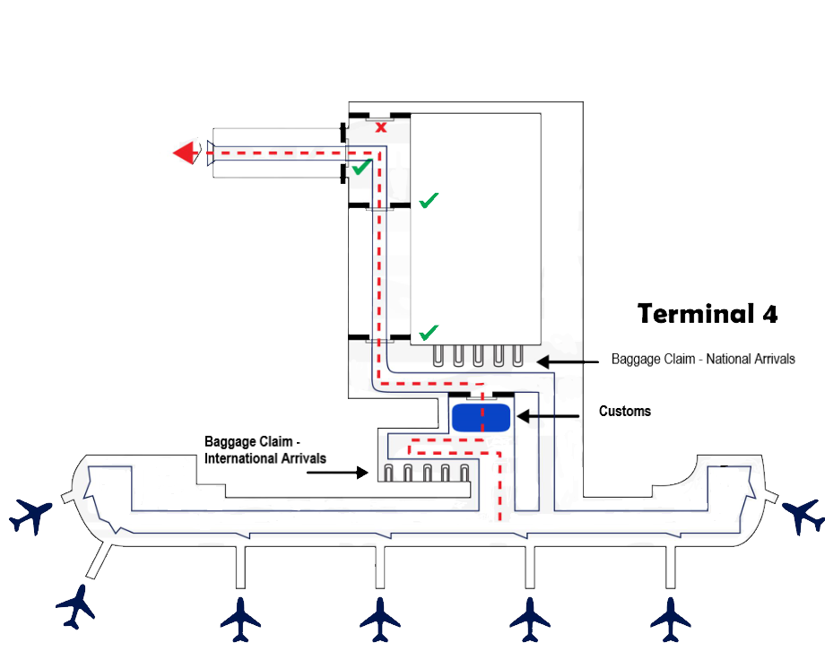

AFTER YOU LAND: 1. Clear immigration. 2. Get your bags. 3. Clear Customs. 4. Exit customs take your left, walk down the hall, turn right straight ahead, pass two more sets of sliding doors, walk until you reach the TOUR OPERATOR- HOTEL SHUTTLE exit on the left-hand side.

Warning! Do NOT go through the “family and friends” exit, as it will take you straight to the pirates! If you do, we cannot get you back.

REMEMBER: Once you exit the Tour Operator-Hotel Shuttle door on the left-hand side, walk straight ahead to meet the ADE DMC staff. They will be holding a sign with your name and the ADE DMC logo.

