Terminal 2
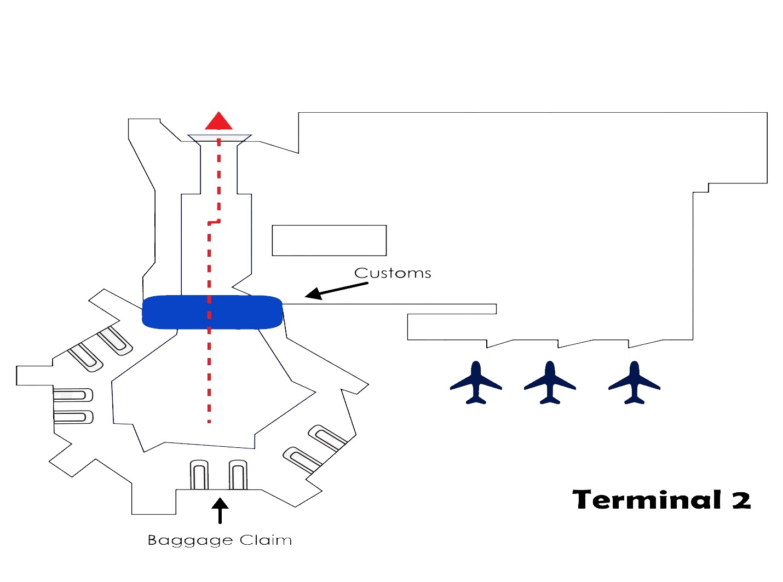

AFTER YOU LAND: 1. Clear immigration. 2. Get your bags. 3. Clear Customs. 4. Exit customs walk down the hall, turn right and go straight ahead, exit the last sets of sliding doors that reads TOUR OPERATOR- HOTEL SHUTTLE.

We will be OUTSIDE of the building. Look for the ADE DMC staff, holding a sign with your name and our ADE DMC logo. As a reference, once outside to the left there is a Meeting point bar & café, do NOT go any farther. Do not accept assistance from anyone other than an ADE DCM representative.

